Online Registration
Overview
If you wish to register on line, you will need to set up an account in our UltraCamp online camp registration website. Then, in order to complete your registration online you will be asked to pay your deposit by E-check. The E-check process is secure, however, if you would prefer using a regular paper check, please register using our paper form instead.

How to Register Online – Welcome to CFC/UltraCamp!
- Browse to www.ultracamp.com/clientlogin.aspx?idCamp=109 or click the link on the CFC website.
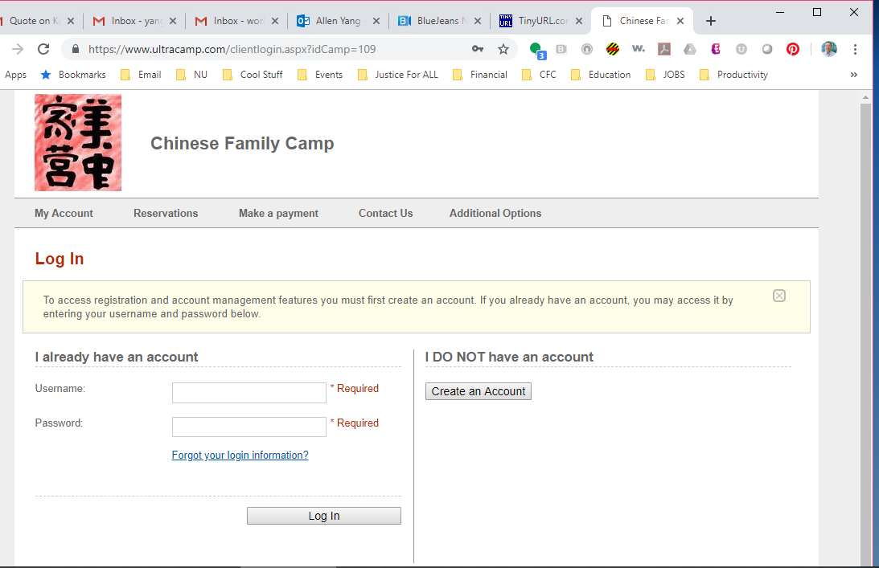
- Click the “Create an Account” button under “I DO NOT have an account.” Choose “Individual/Family” for the Account Type. Enter the required information for the primary adult contact. You may also add a secondary adult contact on this first page. Once you have entered your information, click the “Create Account” button on the bottom right.
- If you get an error message at this point stating “The user name you have selected is already in use,” follow the “Resolving Account Issues” instructions on the next page.
- If you are only registering one or two adults and no children, then you are all set to click “Register for camp” and skip to step 4.
- If you are registering children or more adults, proceed to step 3.
- Click “Add a person to my account” and enter the required information. If you have added everyone who will be attending camp this year, click “Save and Make Reservation.” If you have more attendees to add, click “Save Person” and repeat this step until all attendees have been added.
- Register for this year’s camp!
- The form will ask who is attending, whether you will be attending for the full week or part of the week, and what types of room(s) you would like. The form cannot automatically determine meal selection, so it will also ask how many adult and child meals your family/group will need.
- If you need to add any notes or special requests, there is a question section where you can do so. There is also a section that lists our discounts for this year.
- NEW CAMPERS! If you are a new camper using one of our special discounts, please choose the one that applies to you.
  - Half off for the week
  - Weekend Intro rate
  - You will see different sections depending on your answers. If you think you’ve chosen the wrong option, you can use your browser’s back button to change previous selections. If you do not complete your registration in one sitting, your selections may be lost (any information submitted in steps 1-3 will be saved). If you need to make changes to your registration after you have submitted it, you can log back in and edit your reservation or contact us and have us change it.
  - Please note that you will be asked to e-sign our liability waiver and use an E-check to pay your deposit. Your first E-check deposit may take 8-12 business days to clear, but the time should be much shorter if you use the same account in the future.
  - If you have any questions about creating an account, using the online registration form, or anything else, please don’t hesitate to contact us!

Contact Us
- E-mail: Camp Director Lawrence Wang at registrar@chinesefamilycamp.com
- Call: Allen Yang at 708-669-6556
- WeChat: Lesley Lee (李可忻) at WeChat ID: lklee3in1

Resolving Online Account Conflicts

“The user name you have selected in already in use.”

This is the first year that we are using online registration, but this is not the first year that Chinese Family Camp has used the UltraCamp online database to keep track of invoices, etc. Because we have used the database before, it is possible that Chinese Family Camp administrators created an account that lists the same e-mail address with which you tried to create an account. This is why you may see a message stating: “The user name you have selected is already in use.” In that case, please follow the steps below:

- Click the “click here” link in the text “If you have already set up an account, click here to login.”
- Click the “Forgot your login information?” link under “I already have an account.”
- Choose “I need to reset my password” and “E-mail” (do not choose text, as the account you are trying to access may not have your correct phone number).
- Enter the same e-mail address you used for the primary contact. Enter the security code and then click the “Reset Password” button in the bottom right.
- Check your e-mail account that you used for the primary contact. Within a few minutes you should receive an email from Allen Yang with the subject line “Chinese Family Camp - Password Reset.” Open that message and click the “Reset my password” link.
- Enter the same e-mail address and create a new password that is at least 6 characters long. Then click the “Reset Password” button.
- Click the “Go to the login page” link.
- Enter the same e-mail address and your new password under “I already have an account” and click the “Log In” button. This should take you to your account information.
- Verify that every attendee you would like to register is listed under “Account Members” on the right. If so, you are ready to register! Click “Register for Camp” under “Common Tasks” on the left and see the notes in step 4 of “How to Register Online” above. If you need to add attendees, click “Add a Person to my Account” under “Common Tasks” on the left and return to step 3 of “How to Register Online” above.

